**Capt. Lauren Kram, No. 10, Spirit Number 711**

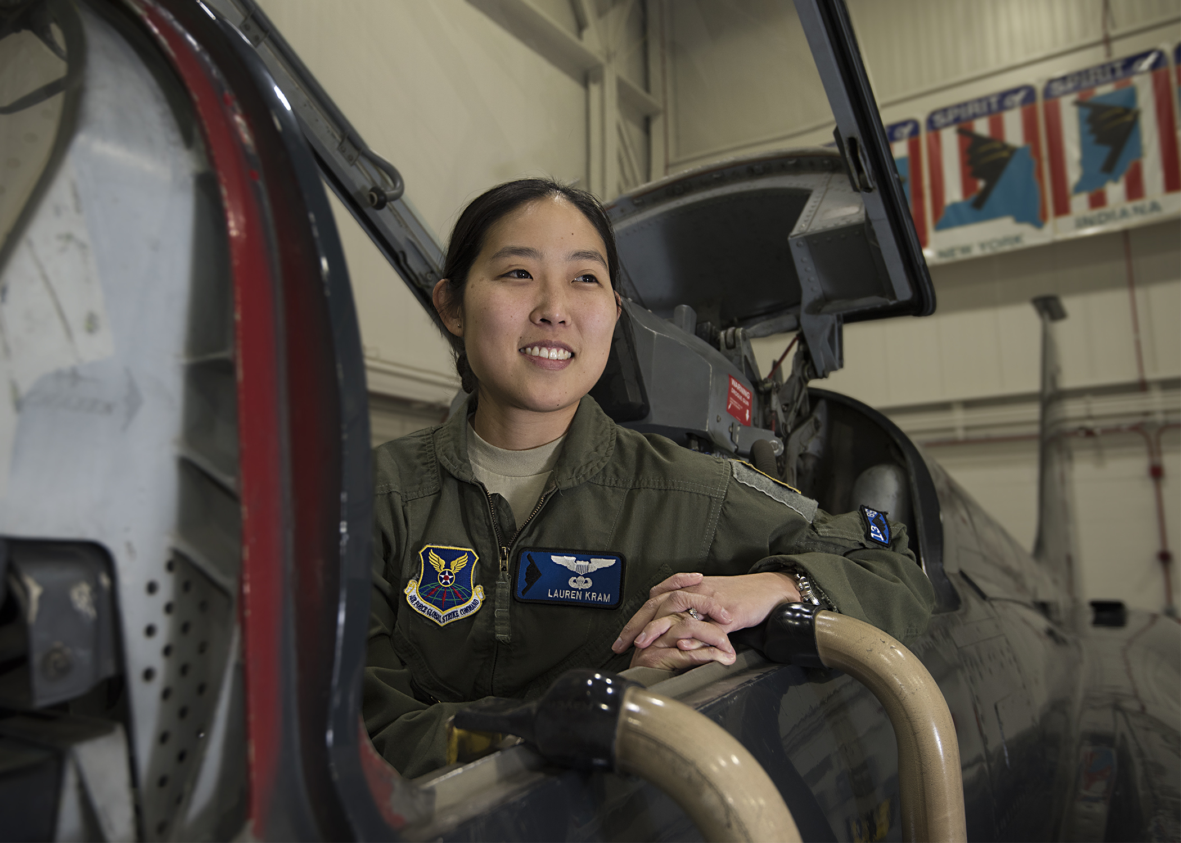

**By Brye Steeves**

**509th Bomb Wing Public Affairs**

Lauren Kram didn’t realize she was No. 10.

In fact, it doesn’t really occur to her that she’s unique.

“I kind of forget about it most of the time,” Kram says. “I’m never reminded that I’m different.”

Barely acknowledged by her and those she serves alongside is that she’s a female pilot. Kram makes up the 6 percent of the female aviators in the Air Force and, having just graduated from the rigorous initial qualification training course in October 2019, is the 10th woman to pilot the B-2.

There are subtle hints of this difference, such as getting fitted for female-specific flightsuits, or when it comes time for official travel and her male counterparts are paired up to room together and she bunks alone.

“But it’s no big deal,” she says.

What is more surprising are the reactions she gets from strangers – little girls who catch a glimpse of her in uniform at the store, or at a remote airfield in eastern Europe and being told she was the only “lady pilot” the awestruck bystanders had ever seen.

Kram’s response to these situations: “There’s actually starting to be a lot of us!”

Prior to going to the U.S. Air Force Academy, Kram had never met a female pilot or even a female military member. But, she said, as a cadet everyone asks everyone else – regardless of their gender – if they’re going to pursue aviation after graduation. Upon receiving an incentive flight there, her answer was a resounding “yes.”

Kram first flew C-21s, which are used to transport cargo and passengers, including patients for aeromedical evacuation operations. She said her desire “to be at the tip of the spear” and the B-2’s mission of lethal global strike and its nuclear capabilities led her to Whiteman Air Force Base last year.

It was then that someone mentioned to her in passing, “Oh, you’re No. 10.”

Kram’s reaction: “OK, cool.”